**Analysis of Tile based Belief Propagation Algorithm**

**1.Introduction:**

A Belief Propagation (BP) on Markov Random Field models is an approximation algorithm used for problem of stereo and image restoration. BP method is a good in the sense that they find minima over large neighborhoods and it produces highly accurate results in practice so Belief Propagation (BP) approach is global method approach.

One can choose either global methods like Belief Propagation (BP) or graph cuts which produce good results but are slow where as local methods such as block matching gradient method and feature matching use local constraints with in window which produces substantially poor results but are fast.

Despite having advances Belief Propagation (BP) approach still requires several minutes of processing time and too slow for practical use.

**2.Markov Random Field(MRF):**

MRF are undirected graphs that encode spatial dependencies.MRF graphical model consists of nodes and links. The nodes consists of observed and hidden variables. The observed variable represents pixel intensity values of an image .The hidden variable values are referred as labels, labels represents disparity values which are trying to find. The link between the each node represents a dependency.

The markov assumption is that a node state depends on its immediate neighbors, so that it allows solving for the hidden variables in a reasonably efficient manner.

The stereo problems can formulate in terms of MRF as energy function .The energy functions contains two functions which are known as data cost and smoothness cost. The energy function basically sum up all the cost at the each link given in an image with corresponding labeling.

Let P be the set of pixels in an image and L is set of labels. The labels corresponds to the quantity want to estimate at each pixel such as a disparities intensities or flow vectors.

A labeling f assigns a label f p L to each pixel p $∈$ P.

Assume that labels should vary smoothly almost every where but may change dramatically at some places such as object boundary.

The quality of labeling is given by an Energy equation,

$E\left(F\right)=\sum_{(p,q)∈N}{V\left(fp,fq\right)+\sum_{p∈P}{Dp(fp)}}$………………………..(1)

Where N are edges in the four connected image grid graph

* V(fp ,fq) is the cost of assigning labels fp & fq to two neighboring pixels which is normally referred as the discontinuity cost.
* DP(fp) is the cost of assigning label fp to pixel q which is referred as the data cost

Finding a labeling with minimum energy corresponds to the Maximum A-Posteriori (MAP) estimation problem for an appropriately defined MRF.

**3.The general frame work of LBP on MRF:**

The BP approach is used for performing inference on Markov random Fields. In particular ,the max product algorithm can be used to find approximate minimum cost labeling of energy function as in the form of above given equation.

The max product algorithm is defined in terms of probability distributions but an equivalent computations can be performed with negative log probabilities where max-product becomes min-sum. This formulation can be used because it less sensitive to numerical artifacts and it uses the energy function definition more directly.

The max-product BP algorithm works by passing messages around the graph defined by the four connected image grid.Each message is a vector of dimension given by the number of possible labels.

Let mtpq be the message that node p sends to a neighboring node q at time t.

When using negative log probabilities all entries in m0pq are initialized to zero ,and at each iteration new messages are computed in the following way

$m_{pq }^{t}\left(f_{q}\right)=\min_{fp} ( v\left(f_{p}f_{q}\right)+D_{p}\left(f_{p}\right)+\sum_{s∈N\left(p\right)\backslash q}{m} \left(f_{p}\right) )$………………..(2)

Where N(P)\q denotes the neighbors of p other than q. After T iterations a belief vector is computed for each node.

bq(fq) =Dp(fp) +…………………………………………..(3)

Finally, the label fq that minimizes bq (fq) individually at each node is selected.

The standard implementation of LBP algorithm on graph runs in O(nk2T)time.

* Where n is number of pixels in the image
* K is number of possible labels for each pixel
* T is number of iterations.

Basically it takes O(k2)time to compute each message and there are O(n)messages per iterations.

**The drawbacks of BP algorithm**

Generally BP algorithms require a great amount of memory for storing the messages in the order of ten to hundred times larger than input data. Since each message is processed hundreds of times ,loading of messages consumes considerable bandwidth. Furthermore since messages are sequentially updated and each message constructed through a sequential procedure, it is difficult to utilize hardware parallelism to accelerate BP

The drawbacks of BP algorithm can be overcome by Tile based BP algorithm

1. The new message processing scheme called tile based Belief Propagation. The key idea of this method is split the MRF in to tiles and perform BP within each tile. To preserve the global optimality the out going boundary messages of a tile are stored and use them when performing BP in neighboring tiles.

The Tile base BP requires 1-5% of memory and 0.2-1% bandwidth of the ordinary BP.When smoothness term in MRF is linear or quadratic,the messages can quickly constructed using min-convolution method but which is sequential process which cannot performed in parallel.

1. The second method is an message construction algorithm in which robust function is used as smoothness terms in energy function. In which many variables are repetitive, therefore they can be calculated once and reused many times.

The mentioned methods are suitable for efficient hardware implementation.

**4,Basic concept of tile based BP**

The process of generating outgoing messages of node ‘p’,

According to equation (2) requires four incoming messages towards ‘p’the data cost of ‘p’ and smoothness cost between p and q.

This concept is used in Tile based BP,

1. Where nodes are split into two sets so that every edge connects to two nodes of different sets.
2. The data required to generate p is the datacost of p’s neighbors message sent from the neighbors of the neighbors.

Again no need to access the varibles outside the groups of these nodes.

1. To generate the messages from shaded nodes to the p neighbors as shown in the diagram needs message from their neighbors. If messages from the boundary region are known, can generate messages sequentially inward. After reaching the region centre, then outward message can generated sequentially
2. So that required inputs are data cost, smoothness cost of the region and messages of boundary nodes.

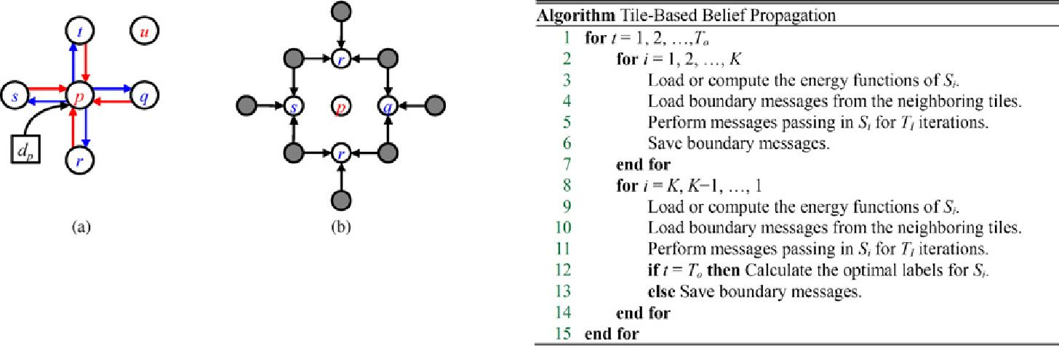

Blue arrows shows required to find message from p to its neighbors.

To find message towards neighbors of p node ie. q, r, s, t(shown by outward arrows) requires to access the messages towards (ie. inward red arrows) and data cost dp. The message related to node ‘u’ is not required.

This concept can be extended into multiple region and iterations.

* Split the MRF into two sets.one set N1 contains nodes in 3 by 3 tile, other N2 contain all other nodes.
* Perform the BP in N2 without knowing the messages in N1,only need the messages coming from N1 to drive the propagation. All the messages in the tile are irrelevant to the message passing outside the tile because they never used in evaluating.
* Similarly when performing BP in N1 beside messages coming from N2 other messages outside the tile are unimportant as long as the incoming messages carry the reliable information about the outside ,BP is used to calculate beliefs for the nodes in the tile.

This is explained by diagram shown below

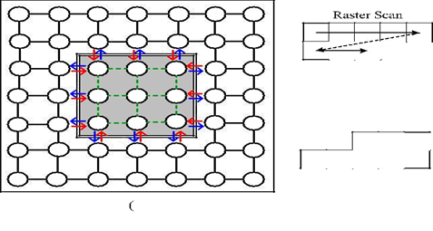

**The performance analysis of Tile based BP:**

The performance of Tile based BP depend on the following factors:

* Number of Outer iterations (T0)
* The tile size (B)
* The number of inner iterations in the message passing steps

The complexity of the tile based BP depends on Ti  & To with 2TiTo iterations in software implementation.

However in hardware implementation the B.W consumption is major performance bound only depends on T0.The Ti iterations in each tile can be performed efficiently without accessing main memory